AI ASSISTED CODING ASSIGNMENT – 18.1
N. SATHWIK (2303A51032)
BATCH-01
Task 1 – Weather API Integration
Connect to a Weather API to fetch current weather details for a given city.
Instructions:
• Prompt AI to generate Python code using the requests library.
• Handle errors: invalid city name, API key errors, and network failures.
• Display temperature, humidity, and weather description in a readable format.
Expected Output:
• A working Python script that fetches and displays weather data with proper error handling.
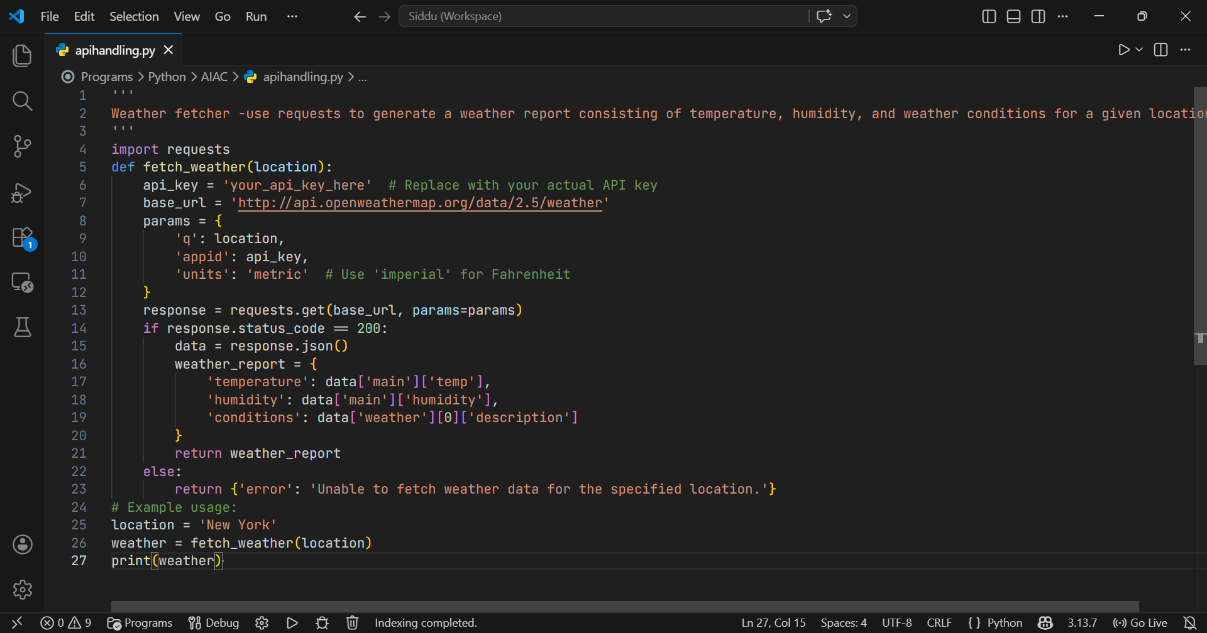

Task 2 – Currency Exchange Rates
Integrate a Currency Exchange API to convert INR to USD, EUR, and GBP.
Instructions:
• Use AI to generate API request code.
• Validate user input for amount and currency codes.
• Implement error handling for invalid responses and API downtime.
• Show conversion results clearly in tabular format.
Expected Output:
• A script that converts INR to multiple currencies with graceful error handling.
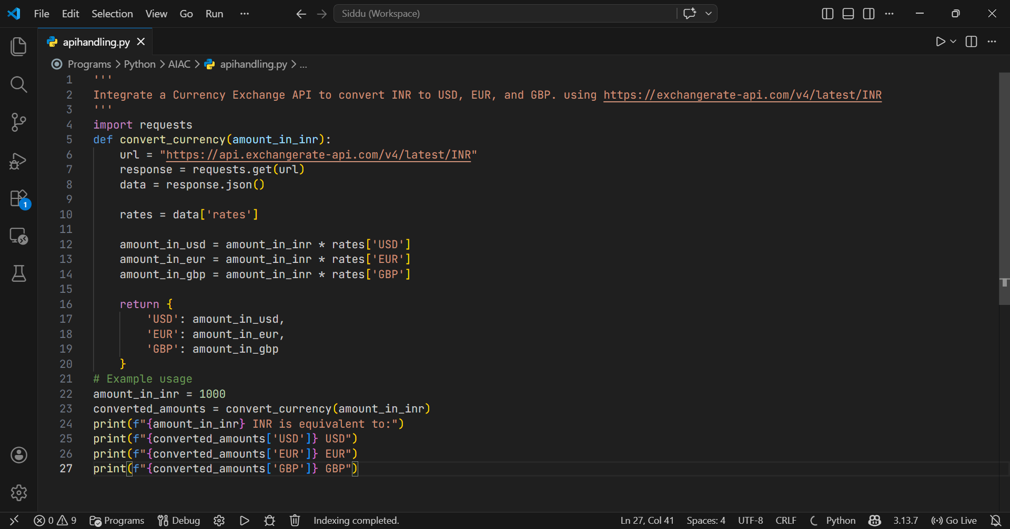

Task 3 – GitHub Repository Info Fetcher
Connect to the GitHub API to fetch details of a repository (e.g., stars,forks, issues).
Instructions:
• Prompt AI to write a Python function to send GET requests to GitHub API.
• Handle rate limit errors, 404 (repo not found), and invalid input.
• Display repository name, description, stars, forks, and open issues.
Expected Output:
• A Python program that retrieves and displays GitHub repository information with robust error handling.
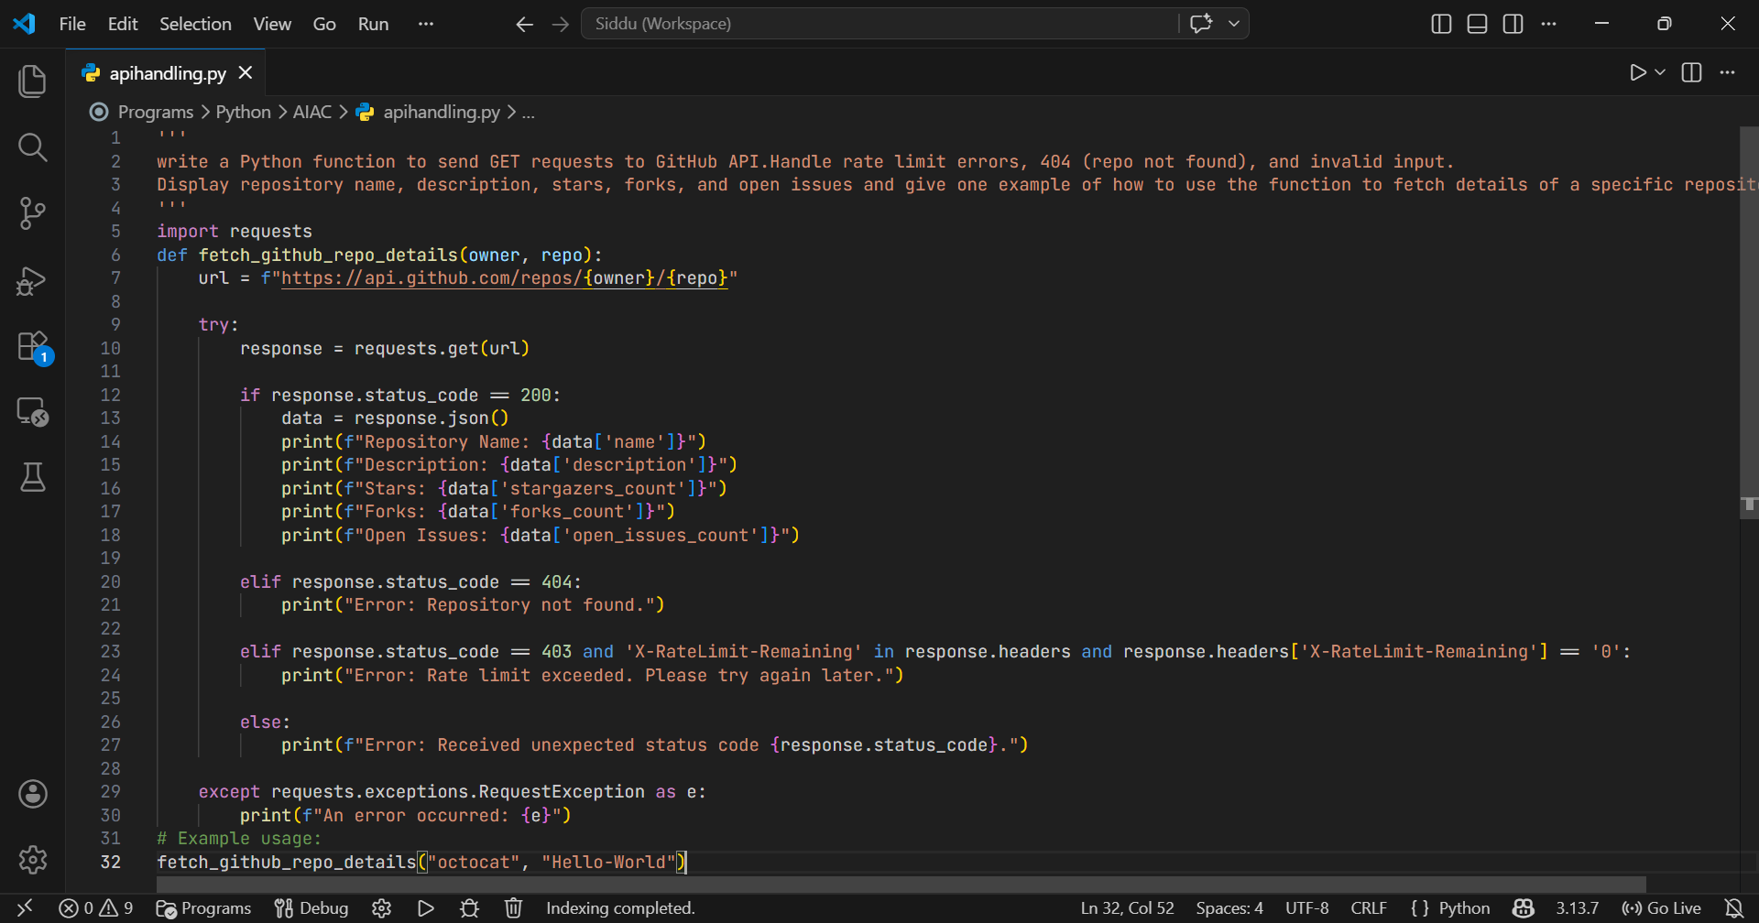

Task 4 – Real-Time Application: News Headlines Aggregator
Scenario: Build a News Aggregator using a free News API.
Requirements:
• Fetch top 5 headlines for a given category (sports, technology, health).
• Handle errors like invalid category, missing API key, and request failures.
• Display headlines in a user-friendly numbered list format.
• Include a retry mechanism if the first request fails.
Expected Output:
• A working Python script that retrieves and displays news headlines with proper error handling

